EXPERIMENT: LEX PROGRAM TO IDENTIFY AND PRINT HTML TAGS

1. AIM
To write a LEX program to identify and print all HTML tags present in a given HTML file.

2. ALGORITHM
- Start the program.
- Check whether the input filename is provided as a command-line argument.
- Open the HTML file in read mode.
- Check whether the file has opened successfully.
- Assign the file pointer to yyin.
- Call the yylex() function to scan the file.
- Identify HTML tags using a regular expression.
- Print all identified HTML tags.
- Close the input file.
- Stop the program.

3. PSEUDOCODE
BEGIN
IF argument count is not 2 THEN
PRINT usage message
EXIT
END IF

OPEN input HTML file

IF file cannot be opened THEN
PRINT error message
EXIT
END IF

SET yyin to input file
CALL yylex()
CLOSE input file
END

4. PROGRAM
File name: htmltags.l
%{
#include <stdio.h>
%}

%%
<[^>]+> { printf("HTML tag: %s\n", yytext); }
.|\n ;
%%

int yywrap(void)
{
return 1;
}

int main(int argc, char *argv[])
{
if (argc != 2)
{
printf("Usage: %s input.html\n", argv[0]);
return 1;
}

FILE *fp = fopen(argv[1], "r");

if (fp == NULL)
{
printf("Error opening file!\n");
return 1;
}

yyin = fp;
yylex();

fclose(fp);
return 0;
}

5. SAMPLE INPUT
File name: input.html
<html>
<body>
<h1>Hello</h1>
</body>
</html>

6. SAMPLE OUTPUT
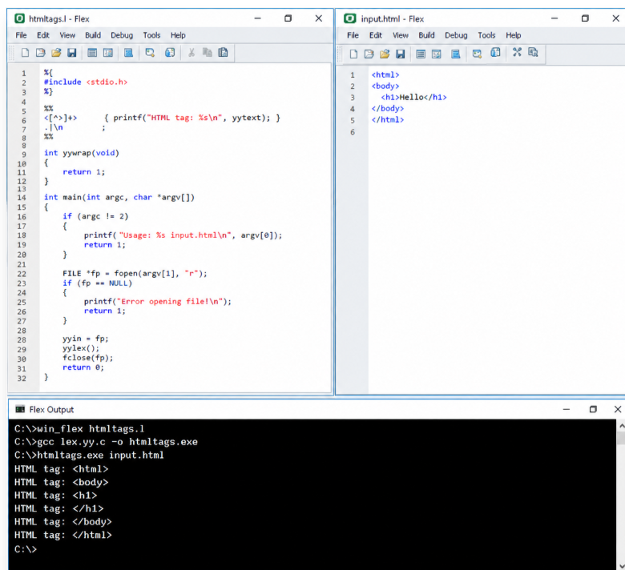

7. EXECUTION COMMANDS
If FLEX and GCC are installed, run the following commands in the terminal:
win_flex htmltags.l
gcc lex.yy.c -o htmltags.exe
htmltags.exe input.html
On Linux, use:
flex htmltags.l
gcc lex.yy.c -o htmltags
./htmltags input.html

8. RESULT
Thus, the LEX program to identify and print all HTML tags present in a given HTML file was written and executed successfully.

